WPL Newsletter November 2017

[Samuel: please use this new header with WPL logo to the right]
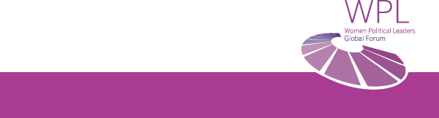

Editorial

Dear Women Political Leaders, dear friends,

‘Never forget that a political, economic, or religious crisis is enough to cast doubt on women’s rights. These rights will never be vested. You have to remain vigilant all your life.’ Simone de Beauvoir’s warning is as relevant today as it was in 1949. More than a decade of data has revealed that progress is still too slow for realising the full potential of one half of humanity within our lifetimes. It is even worse – there is an increase in the number of years to the day when there is no difference in opportunities for a child, no matter if it is born as a girl or as a boy: from below 100 years in 2014, to more than 200 years from today. This worrying trend stems from the Global Gender Gap Report, in which the World Economic Forum quantifies each year the magnitude of gender disparities and tracks their progress over time. It has a specific focus on the relative gaps between women and men across four key areas: health, education, economy and politics. The 2017 Report covers 144 countries. Women Political Leaders can be the trailblazers and role models for opportunities for all women. At the WPL Annual Global Summit in Iceland (28-30 Nov 2017) WPL will gather women trailblazers. With the Summit Motto “We can do it!” WPL stirs the spirit: let’s champion changing the course!

Silvana Koch-Mehrin, Founder & President of the Women Political Leaders Global Forum

News

On 11 October 2017, WPL successfully launched its global #Girl2Leader campaign with simultaneous events in the European Parliament, Canada (House of Commons and Senate) and Malta. The #Girl2Leader initiative aims to get more girls involved in politics by connecting them with female politicians. WPL is honoured to have H.E. Marie-Louise Coleiro Preca, President of Malta, as the Patron of this campaign. The events held on 11 October (‘International Day of the Girl Child’) involved politicians and around 150 girls from more than 20 countries. Some of the highlights of the campaign’s launch were:
- The commitment of women political leaders to work on encouraging more girls to become interested in politics
- The #Girl2Leader “A Call to Action” Declaration
- The participation of YouTubers Swann Périssé (France) & Didda (Iceland)
- The announcement of the creation of a platform where #Girl2Leader delegates will be able to stay connected
- WPL’s commitment to bring the #Girl2Leader campaign to more countries and continents
The next #Girl2Leader event will take place in the Althingi, the Parliament of Iceland, on 30 November on the occasion of the WPL Annual Global Summit 2017.
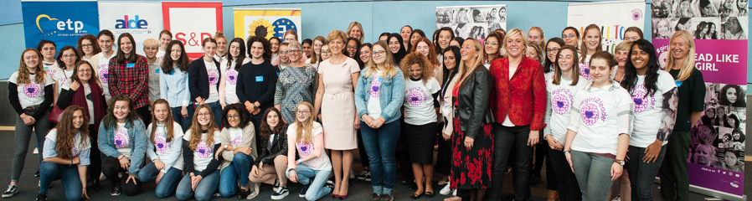

WPL is delighted to announce two new ambassadors to Women in Parliaments (WIP), our most prominent and largest WPL community. WIP Ambassadors are senior Members of Parliaments, appointed by the President of their Parliament, and play a key role in the activities of our WIP community. We are looking forward to a fruitful cooperation with the honourable Members of Parliament Irina Gekht for the Parliament of Russia and Jasna Murgel for the Parliament of Slovenia.
[Samuel: first picture is Gekht; second picture is Murgel. Can you do same as in last Newsletter?]
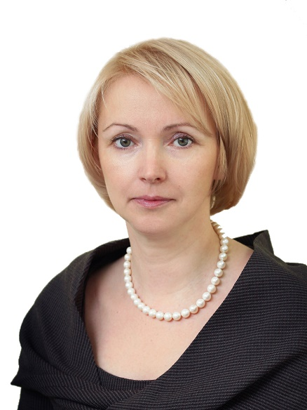

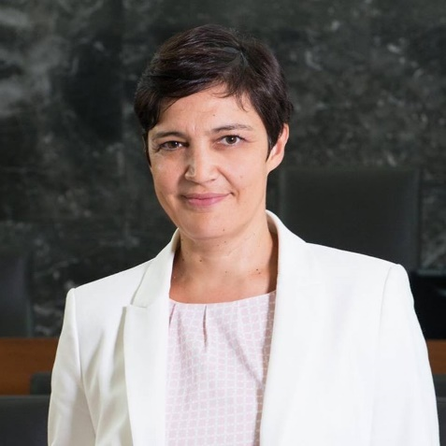

Guest Post
By Hanna Birna Kristjánsdóttir,
Chair of the Executive Board, Women Political Leaders Global Forum (WPL)
former Minister of Interior of Iceland, Member of Parliament of Iceland, and Mayor of Reykjavík

‘Again and again, my home country – Iceland – has been honoured as the best place to be a woman or named the world champion of gender equality. As proud as we all are of that success, we in Iceland remain aware of how much still needs to be done for women to have the same political opportunities and impact as men have. It is thus an honour to host the upcoming Women Political Leaders Annual Global Summit and to partner with the Parliament and Government of Iceland to welcome over 300 women political leaders from 100 countries to Reykjavik. Titled “WE CAN DO IT!”, the WPL Annual Global Summit 2017 will provide a forum for exchange on best practices around the globe: leadership, legislation and political agenda-setting that creates results. We have a great list of prestigious speakers and an enlightening and ambitious agenda. We at WPL really hope that these days in Iceland will provide participants with useful tools for further increasing the number and influence of women in their individual countries. As the chair of WPL's Executive Board, I am much looking forward to greeting this great group of women and I hope that Iceland will welcome them with all its beauty, wonders and magic!’

[Samuel: picture of Hanna to add. Small, like with Foreword and Guest Post in last newsletter]
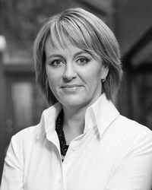

Conferences – past

UNGA: On 21 September 2017, WPL and the Permanent Mission of Italy to the United Nations co-hosted a seminar entitled 'Empowering Refugee and Migrant Women in the Integration Process' as a side event to the 72nd United Nations General Assembly. The seminar drew from best practices in geographically relevant countries Italy, Malta and Jordan. With distinguished speakers, including the High Commissioner of the UNHCR, the seminar was attended by women political leaders from all over the world. Read more here.

OECD: On 11 October 2017, WPL partnered with the OECD Global Parliamentary Network Meeting in Paris, France. On the agenda: OECD Digital Economy Outlook, Inclusive Ageing, Integration of Migrants, Public Sector Innovation and Co-Creation, Doing Politics in New Ways, Budget Transparency and Participatory Budgets. WPL is looking forward to the next joint session in February 2018. Read more here.

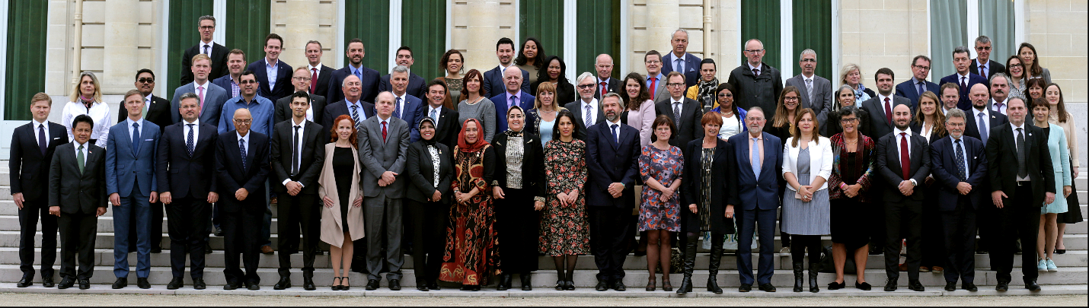

Conferences - upcoming

WHO: On 15 November 2017, WPL will host a Round-table on the Importance of Female Leadership in the Health Workforce at the Fourth Global Forum on Human Resources for Health, in Dublin, Ireland. Read more here.

WPL Annual Global Summit: From 28-30 November 2017, the WPL Annual Global Summit will take place in Iceland, titled “We Can Do It!”. Expected at this year’s WPL Global Summit are around 300 female politicians from 100 countries. The #WPLsummit can be followed via social media, and the plenary sessions will be live-streamed. Read more here.

[Samuel: logo to add to this. Very small; like WebSummit logo in last newsletter]
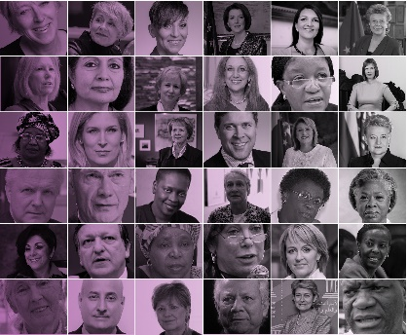

Highlight

Watch the wonderful video YouTuber Didda made for the launch of WPL’s global #Girl2Leader campaign!

<iframe width="560" height="315" src="https://www.youtube.com/embed/SI6P7lq6vfo" frameborder="0" allowfullscreen></iframe>

Calendar

8-9 Nov 2017: WPL Technology Policy Forum at WebSummit (Lisbon, Portugal)

11 Nov 2017: WPL at APEC Summit (Da Nang, Vietnam)

15 Nov 2017: WPL at Global Forum on Human Resources for Health (Dublin, Ireland)

28-30 Nov 2017: WPL Annual Global Summit (Reykjavík, Iceland)

23-26 Jan 2018: WPL will host side sessions at WEF (Davos, Switzerland)

15-16 Feb 2018: WPL Women Peacemakers Conference (Munich, Germany)

