WPL Newsletter September 2017

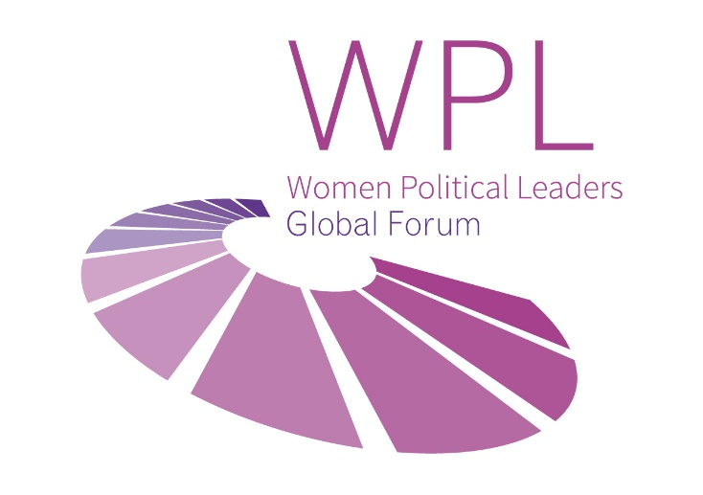

Editorial

Dear Women Political Leaders, dear friends,

VIÐ GETUM ÞAÐ! which means “We can do it!” in Icelandic. The title of the WPL Annual Global Summit in Reykjavik, Iceland (28-30 Nov 2017), is also a good motivator for the many other activities WPL envisages in the coming weeks: a seminar at the UN General Assembly, the launch of the Girl2Leader campaign, deepening the WPL policy work, and more. We expanded our team, for which we would like to express our gratitude to all our supporters and partners. We cordially invite you to read our news, a guest post by Her Excellency the President of Malta, highlights of past and upcoming conferences, to have a look at our agenda and save the dates.

Silvana Koch-Mehrin, Founder & President of the Women Political Leaders Global Forum

News
WPL is delighted to announce three new ambassadors to Women in Parliaments (WIP), our most prominent and largest WPL community. WIP Ambassadors are senior Members of Parliaments, appointed by the President of their Parliament, and play a key role in the activities of our WIP community. We are looking forward to a fruitful cooperation with the honourable Members of Parliament An Capoen for the Parliament of Belgium, Tamar Chugoshvili for the Parliament of Georgia, and Marie Jeanne d’Arc Masy Goulamaly for the Parliament of Madagascar.

Increasing the number and influence of women political leaders globally is an important and a multi-faceted mission. WPL has therefore expanded its team with three new directors: Communications Director Alice Stollmeyer, Program Director Bettina Appel, and Partnerships Director Ross Melzer. Meet our team here.

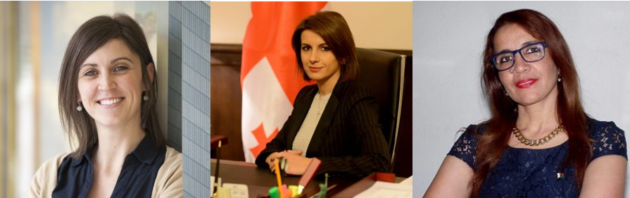

Guest Post
By Her Excellency Marie-Louise Coleiro Preca, President of Malta

'It is an honour to extend my patronage to the #Girl2Leader Campaign, a global campaign of the Women Political Leaders Global Forum. For Malta, I'm happy to announce that it is in collaboration with the President’s Foundation for the Wellbeing of Society, the Network of Young Women Leaders, and the University of Malta’s Student Council (KSU).
I am pleased to announce that, on the 11th October 2017, parallel events will be held in Brussels and Malta, to welcome the #Girl2Leader campaign. These will coincide with the launch of “emPOWer”, Malta’s national platform of women’s organisations.
I am confident that, through our various initiatives, we are actively working together to strengthen the voices of all girls and young women, to embrace professional opportunities in a variety of sectors, to improve their skills, and to reach their goals.
I truly believe that it is only by working in synergy, combining our different capacities and abilities, that we can ensure a future of equity and equality for people of all genders.
Let me encourage us all to continue to lead by example, to ensure that our girls and young women will have the necessary role models to follow, in the process of achieving their aspirations.'

<iframe width="560" height="315" src="https://www.youtube.com/embed/49AiBJ25XUk" frameborder="0" allowfullscreen></iframe>

Conferences - past

On 6-7 June 2017, WPL has participated as an official Friend of the OECD Forum in Paris. The central focus of the forum - organised by the Organisation for Economic Co-operation and Development (OECD) - was on bridging divides at a time of increasing populism and nationalism, historically low levels of trust, rapid technological development, and continued effects of crisis. Read more here.

On 7 September 2017, WPL co-hosted a session on 'Women Land Rights, Climate Change and Sustainable Development' at the Parliamentary Forum on Sustainable Development in Bali, Indonesia. The session built further on WPL's council on economic empowerment (launched in Kenya, December 2016, continued in Cancun, Mexico, 23-25 May 2017). The Indonesian House Representative commented: 'The unique nature of WPL brought in not only members of parliament from your strong community , but also insightful contributions.' Read more & see pictures here.

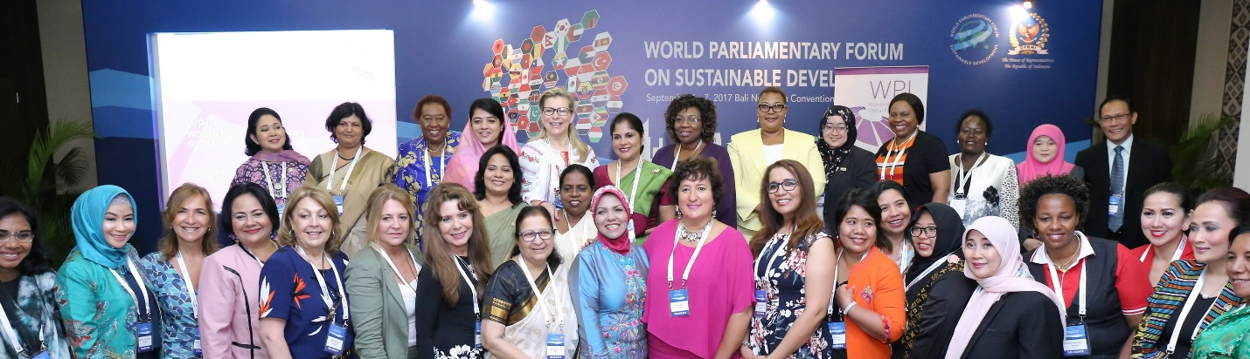

Conferences - upcoming

On 21 September 2017, WPL and the Permanent Mission of Italy to the United Nations will co-host a seminar entitled 'Empowering Refugee and Migrant Women in the Integration Process' as a side event to the 72nd United Nations General Assembly. The seminar will draw from best practices in Italy, Malta and Jordan. Read more here.

On 8 and 9 November, WPL will host a session at Web Summit, the annual tech conference, in Lisbon, Portugal. WPL will also host a Round Table, with the working title ‘Ambition – Women in STEM’. Read more here.

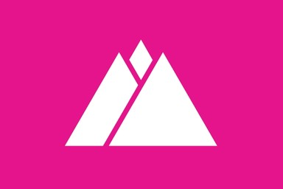

Highlight
Enjoy the video for the WPL Annual Global Summit in Iceland - get a preview!

<iframe width="560" height="315" src="https://www.youtube.com/embed/zrWyfprh26A" frameborder="0" allowfullscreen></iframe>

Calendar

21 Sep 2017: WPL at the UN General Assembly (New York, USA)

25 Sep 2017: second anniversary of the Sustainable Development Goals (global)

26-28 Sep 2017: WPL participates in Debating Security Plus (online)

11 Oct 2017: WPL launches Girl2Leader campaign (global)

11 Oct 2017: WPL at the OECD Global Parliamentary Network Meeting (Paris, France)

6-17 Nov 2017: WPL will host side sessions at COP23 (Bonn, Germany)

8-9 Nov 2017: WPL Technology Policy Forum at Web Summit (Lisbon, Portugal)

11 Nov 2017: WPL at APEC Summit (Da Nang, Vietnam)

28-30 Nov 2017: WPL Annual Global Summit (Reykjavík, Iceland)

23-26 Jan 2018: WPL will host side sessions at WEF (Davos, Switzerland)

15-16 Feb 2018: WPL Women Peacemakers Conference (Munich, Germany)

Connect with us
[Jasmina, is it possible to add all our social media channels here, like on our Summit website, but minus the 'email/contact form' button?]

Update your info/forward/unsubscribe
[Jasmina, here should the buttons go]

The Women Political Leaders Global Forum (WPL)

Boulevard Charlemagne 96
1000 Brussels
+32 27 33 13 44

mail@wpleaders.org

